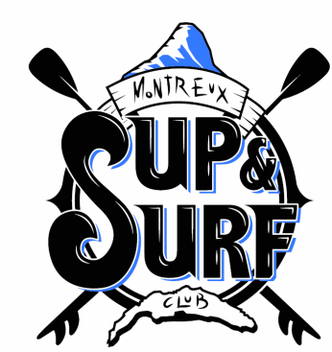
Montreux SUP’n SURF Club
1815 Clarens, Tél. 079 394 94 00, www.montreuxsup.ch
info@montreuxsup.ch, CCP 12-689184-3 or IBAN CH71 0900 0000 1268 91 84 3
Registration form member :
1. Fill in electronically the form below, sign, scan it and send to: info@montreuxsup.ch
2. Pay via bank transfer: IBAN CH71 0900 0000 1268 91 84 3
3. Send payment confirmation to info@montreuxsup.ch
Name : ……………………………………………….First name : ………………………………………….. Birthdate: ………………
Name (s) of the family member(s) if applicable:……………………………………………………………………………………………
Adress : …………………………………………………………………………………………………………
ZIP code: ………………………………………… Town : …………………………………………..
email : ………………………………………………. Cell phone : …………………………………..
Membership (please tick the box) :
€ Adult member: 170.-
€ Student or apprenticed: 140.-
€ Couple: 290.-
€ Family : 340.-
Registration fee 30.- per adult. First year only, includes initiation course.
Rules:
- “Family” or “Couple” membership apply to people who live together and under the same roof and who are listed on the registration form.
- The log book must be filled in with name, board number and time of departure and arrival.
- The equipment shall be use with care. Any loss or damage will be invoiced and paid by the member.
- The member does not have priority over clients when the club is open for rentals. He/she complies with the instructions of the person in charge of the club and waits his/her turn to take the available equipment.
- Equipment remains at the club and cannot be taken outside e.g.excursions or holidays.

SUP outing rules
- The club shall bear no responsibility in case of accident or damage to the material
- It is forbidden to practice SUP under the influence of alcohol, medication or drugs.
- Wearing of the leash is mandatory.
- Wearing of the lifejacket is mandatory beyond 300 meters from the shore.
- Beware of risks of hydrocution due to the difference of temperature between water and air. Wearing of the lifejaket is mandatory when water temperature is below 17 degrees.
- The minimum age required is 10 years. Children under the age of 14 are under the care of their parent or an adult with whom they have come to the beach. Wearing a lifejacket is mandatory.
- Launching and returning to the beach always done on the knees.
- The user must pay particular attention to swimmers and ensure that it does not interfere with the route of the CGN vessels that have priority at all times. It is recommended to paddle in the direction of Vevey and not Montreux in order to avoid the traffic of the CGN.
- Navigation in the port of Basset is prohibited.
- The user follows the instructions given especially regarding changing weather conditions.
- Night outings are prohibited.
Tips for bathing
- Do not jump or dive into unclear or near-shore waters
- It is advisable to get wet before entering the water and practice the SUP and not jump into the water after prolonged exposure to the sun. The body needs time to adapt.
- Wearing the lifejacket is strongly advised to people who only know how to swim poorly.

Read and understood. Name or legal representant: ………………………………………..
Date : …………………………………………………

